

**MATHEMATICS  
Applications Units 3 & 4**

**Test 3 – Graphs**

**Chapter 5**

**Semester 1 2018**

# 

**Section Two – Calculator Assumed**

Time allowed for this section

Working time for this section: 30 minutes

Marks available: 29 marks

## Material required/recommended for this section

##### To be provided by the supervisor

This Question/Answer booklet

Formula sheet

##### To be provided by the candidate

Standard items: pens, pencils, pencil sharpener, eraser, correction fluid, ruler, highlighters

Special items: Nil

## Important note to candidates

No other items may be used in this section of the examination. It is **your** responsibility to ensure that you do not have any unauthorised notes or other items of a non-personal nature in the examination room. If you have any unauthorised material with you, hand it to the supervisor **before** reading any further.

1. (10 marks)  
   The following table gives costs (in $1000) of gas between country centres A to F.

|  |  |  |  |  |  |  |
| --- | --- | --- | --- | --- | --- | --- |
|  | **A** | **B** | **C** | **D** | **E** | **F** |
| **A** | - | 20 | 12 | 8 | - | - |
| **B** |  | - | 9 | 14 | - | - |
| **C** |  |  | - | - | 5 | 11 |
| **D** |  |  |  | - | 8 | - |
| **E** |  |  |  |  | - | 12 |
| **F** |  |  |  |  |  | - |

1. Draw the network. [3]
2. Find the minimum cost of linking all towns to gas. Highlight the connections on the network. [3]

1. Verify the minimum cost by using Prim’s Algorithm on the table. [3]

|  |  |  |  |  |  |  |
| --- | --- | --- | --- | --- | --- | --- |
|  | **A** | **B** | **C** | **D** | **E** | **F** |
| **A** | - | 20 | 12 | 8 | - | - |
| **B** |  | - | 9 | 14 | - | - |
| **C** |  |  | - | - | 5 | 11 |
| **D** |  |  |  | - | 8 | - |
| **E** |  |  |  |  | - | 12 |
| **F** |  |  |  |  |  | - |

The most expensive connection in the planned tree was not made due to a lack of funding.

1. Which town was left unconnected? [1]
2. (7 marks)

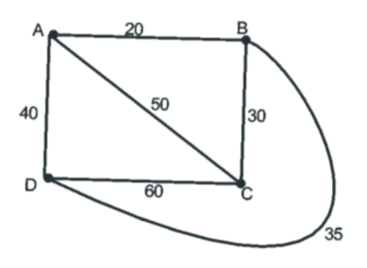Before telephones, carrier pigeons were used to send messages. The following network shows four towns and the travel routes, in km.

A pigeon at town A flies directly to town B, then returns directly to town A. It then flies directly to C and directly back to A. It then flies directly to D and directly back to A.

1. How long does it take for the pigeon to complete this journey if it flies at an average speed of 40kph? [2]
2. Determine the minimum flying distance to fly from A to visit all the other towns, if the pigeon only returns to A after visiting the final town in its journey. [2]

Once telephones were invented, lines were laid to connect towns together.

1. State the minimum length of cable needed to connect the four towns and clearly show this connection of the diagram above. [3]
2. (5 marks)

The diagram below shows a network of train lines between five towns: Attard, Bower, Clement, Derrin and Eden. The numbers indicate the distances, in km, that are travelled by train between connected towns.

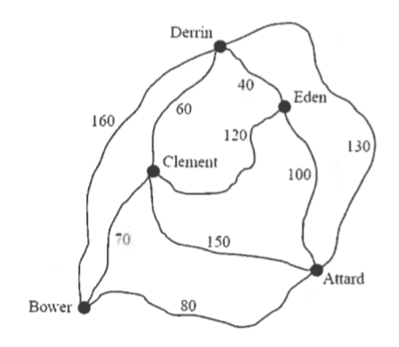

Charlie followed a Eulerian path through this network of train lines.

1. Write down the names of the towns at the start and at the end of Charlie’s path. [2]
2. What distance did he travel? [1]

Brianna will follow a Hamiltonian path from Bower to Attard.

1. What is the shortest distance that she can travel? [1]

The train line between Derrin and Eden will be removed. If one other train line is removed from the network, Andrew would be able to follow a Eulerian circuit through the network of train lines.

1. Which other train line should be removed? [1]
2. (7 marks)

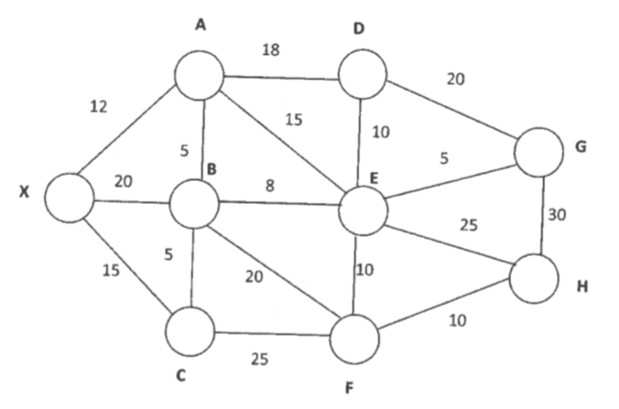The network below represents the road transport network for a product distributor. The network consists of one distribution centre X and eight retail outlets A, B, C, …, H. The number on each edge represents the distance, in km.

1. Determine and state the shortest route from the distribution centre X to H. You must demonstrate reasoning/process. [3]
2. State the distance from the route found in a). [1]



1. The edge GH currently goes around a creek. A bridge is being proposed that can reduce the distance between G and H by x km. For what value(s) of x will the shortest route from X to H definitely use this bridge? Justify your answer. [3]

**End of Test**